Report THEE - research practical Julia Eggenschwiler and Jaelle Häfliger

A computational model for antibiotic resistance

Abstract
In today’s world the problem of antibiotic resistance in bacteria is as important as ever. Especially multi-resistant bacteria strains are a great problem which need more research to counteract as soon as possible. Fitness costs are a known aspect of resistance, that we want to study further with this model, because these insights could help in finding a way to reduce dangerous resistance strains. Overall, the model helps to predict under which circumstances the different resistance mutations will be able to persist in the population and rescue it. Also, we are interested in the changes of frequency of the different mutants in the population. Our expectation, namely that the strongly mutated organisms wouldn´t survive because the costs of their trade off are too high, was not confirmed. We thought the survival of the population would depend on the weakly mutated and strongly beneficial organisms. This prediction was also proven wrong. Both mutations could lead to the rescue of the population, whereas coexistence is very rare.

Introduction
Antibiotics, which proved to be an efficient solution against bacterial infections for approximately 90 years of use, might be soon ineffective against multi-resistant bacteria. (MacGowan und Macnaughton 2017) Additionally, recent medical advancements, especially regarding various surgical procedures and immunosuppressive treatments strongly depend on antibiotics. (MacGowan und Macnaughton 2017) Therefore, this problem could have devastating effects on multiple levels. Recognizing the importance of this concern, we present a model for antibiotic resistance. Despite its limitations, it could help to understand the population dynamics of antibiotic resistance. In the model the application of an antibiotic leads to a rapid decline of the bacterial population. Thus, the antibiotic is the environmental change that threatens the population and raises the need for evolutionary rescue. The latter emerges when a population adapts fast enough to an environmental change to escape extinction. (H. Allen Orr und Robert L. Unckless 2014)With this study our goal is to find out which mutation strain of the bacteria can “save” its population more often and therefore be the cause of evolutionary rescue and how their frequencies in the population change. The bacteria in a population either have a strong or weak deleterious mutation, which arise from the fitness costs of the resistance genes, meaning they could become strongly or weakly resistant (beneficial) as soon as the antibiotic is present. The ones that are strongly deleterious in the beginning, have the genetic composition to become strongly resistant but also suffer higher fitness costs of this resistance gene (strong deleterious) when there is no antibiotic present. (Melnyk et al. 2015)Thus, all strains are at the start of the simulation only in the deleterious form in the population present. Only when the antibiotic is introduced and the population starts to decline, the same resistance gene that had detrimental effects before, has the possibility to become beneficial when the individual is exposed to the corresponding antibiotic. Backmutations are also considered in the model.

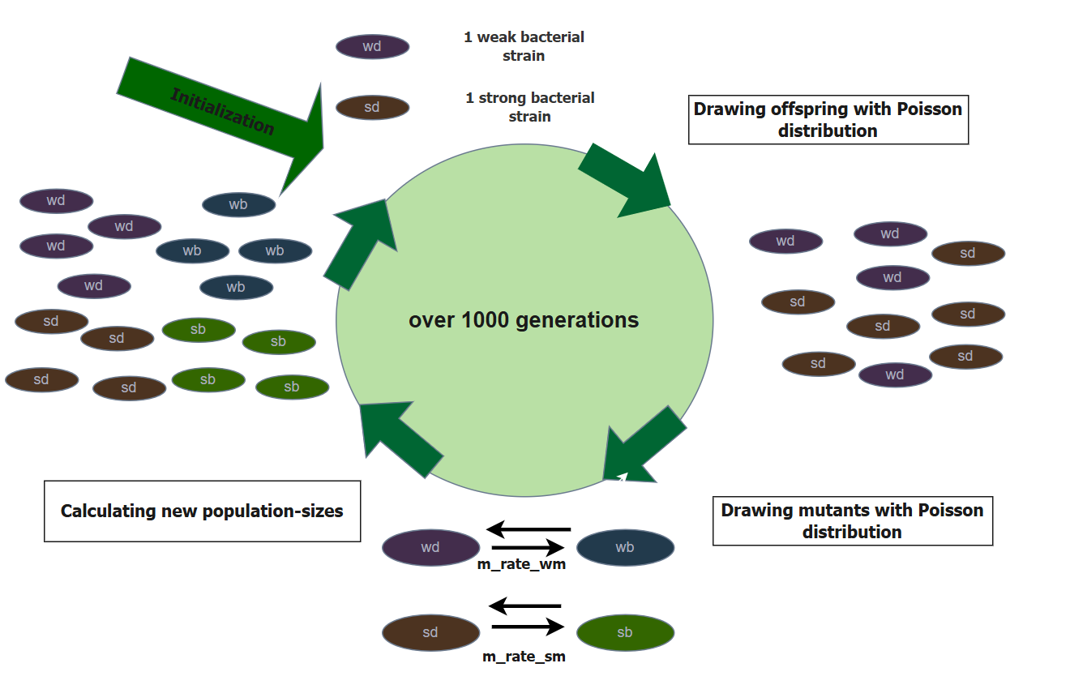
Methods

Figure 1: life cycle of the model, including the different steps the model goes through in one generation, created with draw.io
In Figure 1, the life cycle of our model is visualized, showing one generation. At the initialization point of the model, there are two bacterial strains, indicated with the following abbreviations: “wd” = weak deleterious, and “sd” =strong deleterious. In the first step, we draw offspring, using a Poisson distribution. In the second step we draw mutants, with a Poisson distribution as well. In both strains, the deleterious individuals can mutate to beneficial ones, and in the other direction (backmutation), of course backmutation cannot happen in the very first generation since no beneficial mutants are present yet. The mutation rate of the weak strain is called m_rate_wm (“wd” to “wb” and “wb” to “wd”) and the mutation rate of the strong strain is called m_rate_sm (“sd” to “sb” and “sb” to “sd”). In the last step we calculate the new population sizes of the four mutants. For this calculation we use the following code in RStudio:
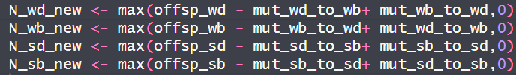
Figure 2: code-lines showing the calculation of the population-size of each mutant, in the function: “simulate_one_gen”, taken from the R-Markdown-file: “Evolutionary rescue_discrete time_Jaelle_Julia.Rmd”

The final simulation is then run until 1000 generations (parameter “max_gen” in the code).

Parameter/Variable | Description | Manipulation
init_wd, init_wb, init_sd, init_sb | initial population sizes of the 4 mutants | Fixed at 30 for the deleterious mutations  Set to 0 for the beneficial mutations
decay_rate_wm | decay rate of the weak mutation | Fixed to 0.05
decay_rate_sm | decay rate of the strong mutation | Fixed to 0.1
s_wm | selection-coefficient of weak mutation | Varied (0.1, 0.15, 0.20)
s_sm | selection-coefficient of strong mutation | Varied (0.25, 0.30, 0.35)
m_rate_wm | mutation rate of the weak mutation | Varied (4e-5, 5e-4, 6e-3)
m_rate_sm | mutation rate of the strong mutation | Varied (7e-5, 8e-4, 9e-3)
rescue_prob | rescue-probabilities of the 4 mutants | calculated
N_end_wd, N_end_wb, N_end_sd, N_end_sb | final population-size of the 4 mutants | calculated
max_gen | number of generations after which to stop the simulation | Fixed to 1’000
Figure 3: table of all parameters and variables used in the model, including a brief description and whether or not they were varied in the simulation

Figure 3 shows all parameters and variables which were used in this model. They rest upon the provided base model. In our simulations, we set the values for the initial population sizes to 30 for the deleterious mutations and to 0 for the beneficial mutations. In some plots we show long-term outcomes with more than 30 per deleterious mutant, but this will be indicated. We use two different decay rates, one for the weak bacterial strain and one for the strong strain. The decay rates are fixed in our model. We have two different parameters for selection coefficients and for mutation rates as well, one parameter for the weak strain and one for the strong strain. We generated plots, in which the two are fixed and in other plots we show the influence of the selection coefficient and/or mutation rate and therefore vary them. This will be indicated in the descriptions of the plots. To answer our question, we calculate the rescue probability. Another deviation from the base-model is that we calculate the end population size (after 1000 generations) for the strong bacterial strain and the weak bacterial strain.
To create and run the simulations we used RStudio version 4.4.1. To run the code, it is required that the R-packages “dplyr”, “ggplot2”, “tidyr” and “knitr” are installed and loaded.
.

Results
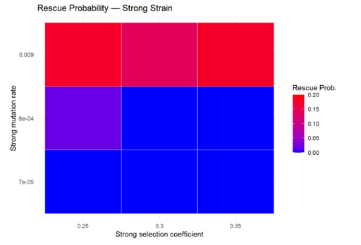
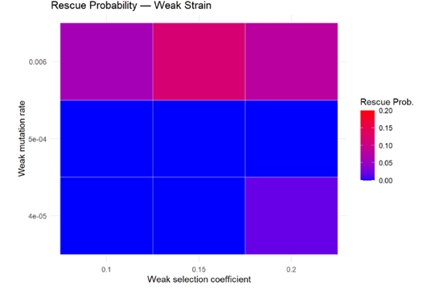
Figure 5
Figure 4
Figures 4 and 5 above show Heatmaps, in which we combined different selection coefficients on the x-axis, different mutation rates on the y-axis, and the rescue-probability, indicated by the colour.
Figure 4 shows the rescue probability of the weak strain with selection coefficients on the x-axis (0.1, 0.15, 0.20) and mutation rates on the y-axis (4e-05, 5e-04, 0.006). In this case, rescue can essentially only be reached with the highest mutation rate of 0.006. Interestingly, with the lowest mutation rate of 4e-05 and the highest selection coefficient of 0.2, sometimes rescue seems to be possible, compared to the other combinations, in which the mutation rate is either 4e-05 or 5e-04. This is indicated by the purple colour, suggesting a rescue probability of about 0.025. However, with the highest mutation rate of 0.006, rescue is possible with all three selection coefficients (0.1, 0.15, 0.20). It becomes visible, that with an intermediate selection coefficient of 0.15 and the highest mutation rate of 0.006 the overall highest rescue probability of about 0.15 can be reached. For the combination of highest mutation rate and selection coefficient of 0.1 and 0.2, the results look similar and produce a lower rescue probability of about 0.10.
Figures 4 and 5: Heatmaps showing the probability of rescue for the two bacterial strains separately (weak strain, strong strain). Indicating slightly higher rescue probability of the strong strain. The x-axis shows the varied selection coefficients for the weak strain (Figure 4) and for the strong strain (Figure 5). The y-axis shows the varied mutation rates for the weak strain (Figure 4) and the strong strain (Figure 5). The colour-bar indicates the rescue probability. The bar goes from blue = rescue probability of zero to red = rescue probability of 0.2.
Parameters used for this plot:
init_wd <- 30, init_wb <- 0, init_sd <- 30, init_sb <- 0. decay_rate_wm <- 0.05. decay_rate_sm <- 0.1, max_gen <- 1000, no_replicates <- 50
s_values_wm <- c(0.10, 0.15, 0.20)
s_values_sm <- c(0.25, 0.30, 0.35)
m_values_wm <- c(4e-5, 5e-4, 6e-3)
m_values_sm <- c(7e-5, 8e-4, 9e-3)

Figure 5 shows the rescue probability of the strong bacterial strain, based on strong selection coefficients on the x-axis (0.25, 0.30, 0.35) and strong mutation rates on the y-axis (7e-05, 8e-04, 0.009).
For the two lower mutation rates (7e-05, 8e-04) the pattern looks similar as in Figure 4. Rescue is not possible for most combinations. In the figure 5, the combination low selection coefficient (0.25) and intermediate mutation rate (8e-04) gives a slightly higher rescue probability, approximately 0.025, than all other combination, in which the mutation rate is not at 0.009. For the highest mutation rate of 0.009, rescue is possible and is overall higher than in the weak strain (figure 4). However, the pattern seems to be reversed. With the lowest and highest selection coefficients (0.25, 0.35) in combination with a mutation rate of 0.009, a rescue probability of about 0.20 can be reached. With the intermediate selection coefficient of 0.30 and the highest mutation rate of 0.009, rescue is lower and reaches approximately a value of 0.15.
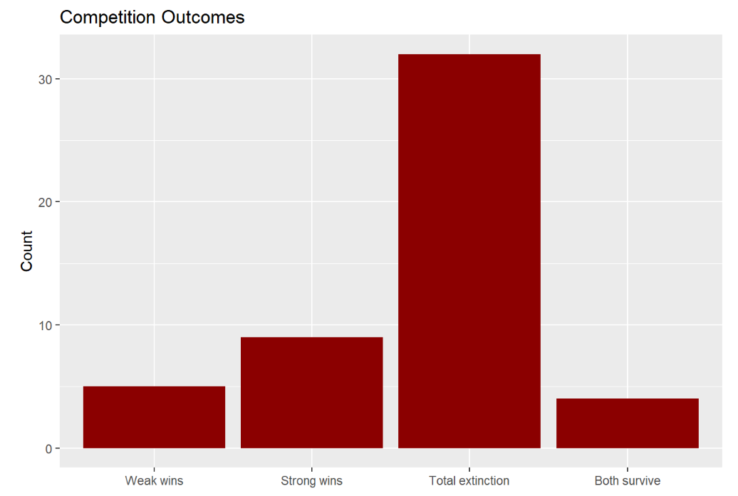

Figure 6: Barplot, showing the results of the competition between the two bacterial strains, on the x-axis the four possible outcomes, that were calculated: “weak wins, strong wins, total extinction, both survive”, on the y-axis the counts of each outcome (how often each outcome occurs). Indicating, that “total extinction” is the most common outcome, followed by “strong wins”.
Parameters used for this plot:
init_wd <- 30, init_wb <- 0, init_sd <- 30, init_sb <- 0. decay_rate_wm <- 0.05. decay_rate_sm <- 0.1, max_gen <- 1000, no_replicates <- 50
s_values_wm <- c(0.10, 0.15, 0.20)
s_values_sm <- c(0.25, 0.30, 0.35)
m_values_wm <- c(4e-5, 5e-4, 6e-3)
m_values_sm <- c(7e-5, 8e-4, 9e-3)

Figure 6 gives an overview of the results of the competition between the two bacterial strains, weak and strong. Total extinction is the most common outcome in our model with more than 30 counts, which could be explained by the low initial population size of 60 in total. The strong strain tends to win more than the weak strain, despite high stochasticity, this is the case in most simulations. In our model, it seems to be possible that both strains can survive after 1000 generations, but rarely. In this simulation only 4 out of 50 replicates reach the outcome: “both survive”.
This same figure can be viewed in the additional information section (figure 6.1), where the initial population-size for weak deleterious and strong deleterious were both set to 60 instead of 30.

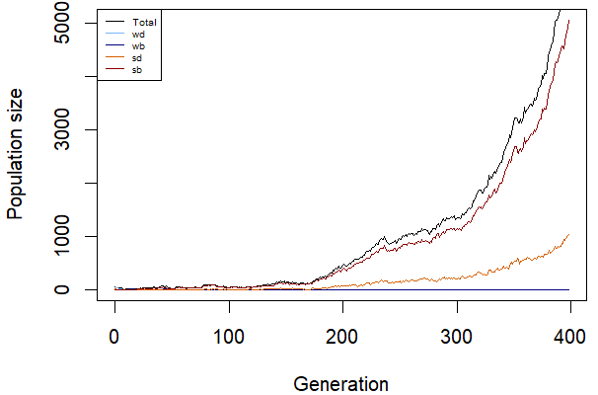
Figure 7: Displays the development of one population and how the frequencies of the mutants change. On the x-axis is the generation with a maximum of 400, while the y-axis represents the population size with a maximum of 5000. The initial number of individuals for the deleterious mutations is 30, while there are no beneficial mutants in the beginning.
Parameters used for the plot:
init_wd <- 30, init_wb <- 0, init_sd <- 30, init_sb <- 0, m_rate_wm <- 0.05, m_rate_sm <- 0.07, decay_rate_wm <- 0.05, decay_rate_sm <- 0.1, s_wm <- 0.1, s_sm <- 0.2

Figure 7 shows the most common outcome if rescue takes place. The initial number of bacteria for the deleterious mutants is 30 and 0 for the beneficial ones. Most of the time the strong mutants take over the population. They always show the same pattern, namely exponential growth where the strong beneficial individuals grow faster than the strong deleterious ones. Much less frequently the weak mutants can thrive, where the exponential growth occurs later (mostly between 400-600 generation). Additionally, the output shows more fluctuations (additional information, Figure 7.1) when the weak mutants rescue the population. Nevertheless, the most common fate of the population is extinction at the latest by generation 60 (additional information, Figure 7.2). Also, we could observe short phases of coevolution and even exponential growth of three mutants (additional information, Figure 7.3) To highlight the different time intervals of the populations we chose different x-and y-axis maximums.

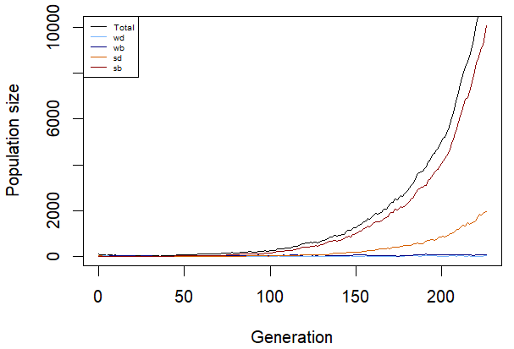

Figure 8: Represents the development of one population and how the frequencies of the mutants change. On the x-axis is the generation until 200, while the y-axis represents the population size until 1000. The initial number of detrimental mutants is 60 but there are no beneficial mutants at the start.
Parameters used for the plot:
init_wd <- 60, init_wb <- 0, init_sd <- 60, init_sb <- 0, m_rate_wm <- 0.05, m_rate_sm <- 0.07, decay_rate_wm <- 0.05, decay_rate_sm <- 0.1, s_wm <- 0.1, s_sm <- 0.2

Moving on to Figure 8, which is the same graph as Figure 7, only that the initial number of the detrimental mutant is now 60. We observed that the frequency of extinction and rescue is about the same. The frequency of the rescue by the strong individuals increases and still shows the same pattern of exponential growth just that it happens faster (at circa 150th generation). On the other hand, the rescue by the weak individuals occurs at the same frequency (Additional information, Figure 8.2). There is also very rare occurrence of indicated coexistence between the mutants (Additional information, Figure 8.3).
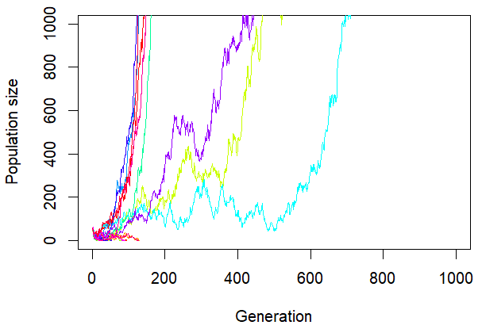
Figure 9: Shows the outcome of 30 populations, each line represents one population. One the x-axis is the generation with the maximum of 1000 and on the y-axis is the population size displayed, with the maximum of 1000. The initial number of individuals for the detrimental mutants is 30 but there are no advantageous individuals at the start. This simulation shows that 9 populations thrive, some grow faster than others. The remaining 21 populations can’t persist.
Parameter used for this plot:
init_wd <- 30, init_wb <- 0, init_sd <- 30, init_sb <- 0, m_rate_wm <- 0.05, m_rate_sm <- 0.07, decay_rate_wm <- 0.05, decay_rate_sm <- 0.1, max_gen <- 1000, no_replicates <- 30, s_wm <- 0.1, s_sm <- 0.2

In the Figure above each line stands for one independent population. There are 30 populations simulated at the same time in the graph. The initial number of bacteria per detrimental mutant is again 30, so an initial population size of 60. It shows a simulation in which 9 populations grow with near exponential growth that differ in their slope, whereas the other 21 populations go extinct within less than 200 generations. Overall, in every simulation at least 5 populations get rescued, a slightly different outcome can be observed in the additional information (Figure 9.1).

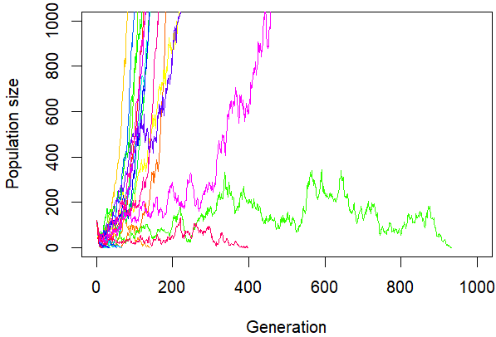
Figure 10: Shows the outcome of 30 populations, each line represents one population. One the x-axis is the generation with the maximum of 1000 and on the y-axis is the population size displayed, with the maximum of 1400. The initial number of the detrimental mutants is 60, while there are no beneficial ones at the start. The simulation shows that 14 populations thrive and grow exponentially with varying slopes. Two populations persist longer than the other populations that die out but also go extinct before 1000 generations (>=400).
Parameter used for this plot:
init_wd <- 60, init_wb <- 0, init_sd <- 60, init_sb <- 0, m_rate_wm <- 0.05, m_rate_sm <- 0.07, decay_rate_wm <- 0.05, decay_rate_sm <- 0.1, max_gen <- 1000, no_replicates <- 30, s_wm <- 0.1, s_sm <- 0.2

Figure 10 displays again the same simulation as in Figure 9 just that the initial number per deleterious mutant changed to 60. At first sight, we can see that more populations are able to thrive than before with a total population of 60, more precisely about 2 times more survive (always more than 10 populations). In Figure 10, 14 populations get rescued, whereas the others die out, two survive longer than the others until they face extinction (>=400 generations). Therefore, about half of the populations go extinct, the other half survives. Another output of the simulation is available in the additional information (Figure 10.1).

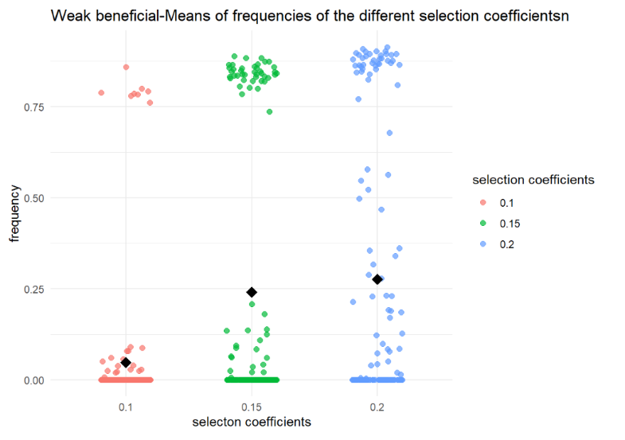
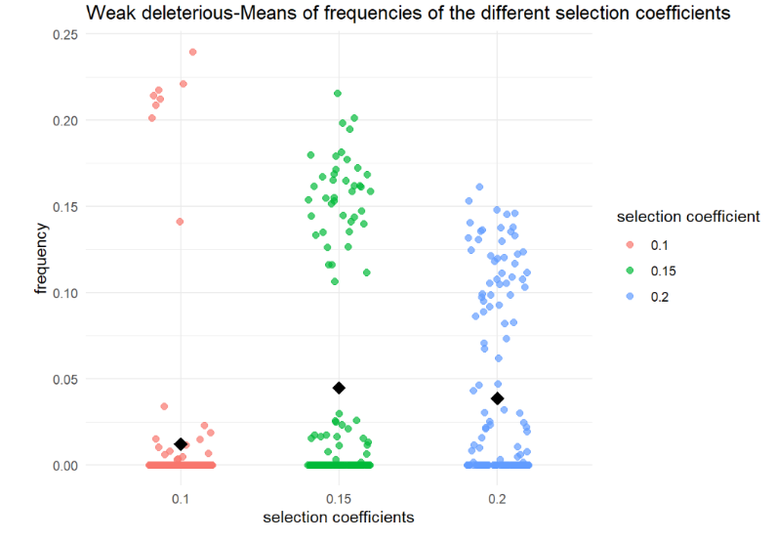
Figure 12

1:
Figure 11

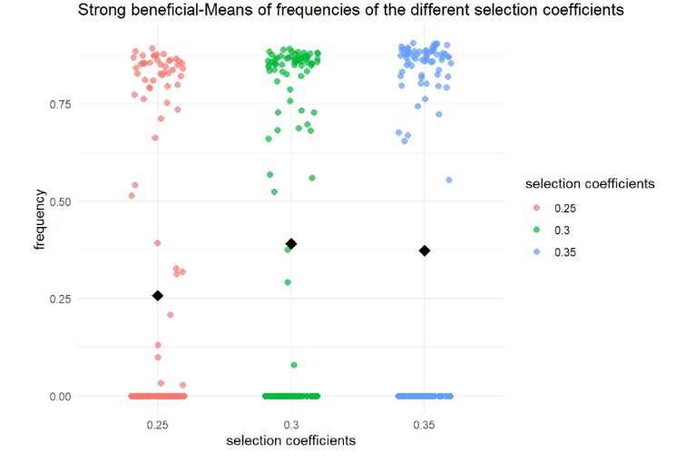
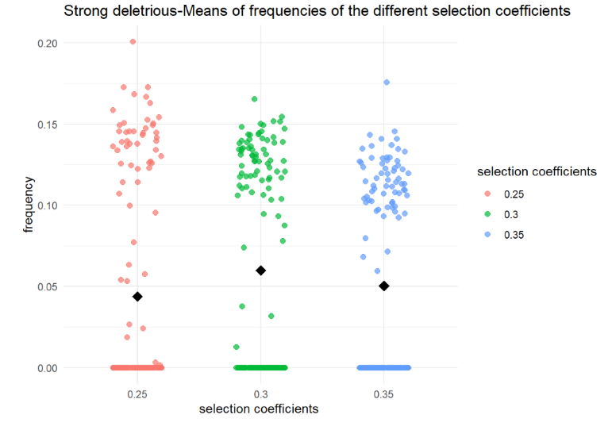

Figure 14

Figure 13

Figures 11-14: Scatterplots showing the frequency of each mutant separately dependent on different selection coefficients. Indicating, that the frequency of “strong beneficial” seems to be higher than “weak beneficial”. The x-axis shows three different selection-coefficients, and the y-axis shows the frequency. For figure 11 and 12 (weak deleterious and weak beneficial three weak selection coefficients were used. For figure 13 and 14 (strong deleterious and strong beneficial) three strong selection coefficients were used.
Parameters used for these plots:
init_wd <- 30, init_wb <- 0, init_sd <- 30, init_sb <- 0, m_rate_wm <- 0.05, m_rate_sm <- 0.07, decay_rate_wm <- 0.05, decay_rate_sm <- 0.1, max_gen <- 1000, no_replicates <- 50, s_values_wm <- c(0.10,0.15,0.2), s_values_sm <- c(0.25,0.30,0.35)

In the figures 11-14 above, we plotted the frequency of each mutant separately with different selection coefficients. For the weak deleterious and weak beneficial mutation (Figures 11 and 12) we used the selection coefficients 0.1, 0.15 and 0.20. The purpose of these plots is mainly to show the effect of each mutation on a population and how the frequencies differ. Another aspect is to show the stochasticity of our model, using scatterplots, where every point represents one of a total of 50 replicates that were simulated. Since the model includes a weak strain and strong strain, we chose 3 selection-coefficients for each of them. Figure 11 shows the plot of the weak deleterious strain. Frequencies are very low, going from a mean of almost 0.0000 for the lowest s of 0.1 to 0.05 with an s of 0.15 to approximately 0.04 with the highest s of the weak mutation (0.20).
Figure 12 shows the frequency of the weak beneficial mutation. With increasing value of the selection coefficients, the frequency increases. With the highest selection coefficient of 0.20, the mutation reaches a frequency of almost 0.25. There are big differences, since with the lowest selection coefficient of 0.10 the mean frequency is only about 0.05, with many cases in which the frequency is 0.00. To visualize the results better, the y-axes show different scales, so that the frequencies of the deleterious mutations can still be visualized.
For the strong deleterious and strong beneficial mutation (Figures 13 and 14) we used the selection coefficients 0.25, 0.30 and 0.35. Figure 13 shows the frequency of the strong deleterious mutation. Variation is significant in this mutation. The lowest s of 0.25 results in a mean frequency of almost 0.05. The s 0.30 has the highest frequency of 0.06 and with 0.35 the frequency is 0.05. But overall, the frequencies are quite similar.
Figure 14 shows the frequency of the strong beneficial mutation. With the lowest s of 0.25 variation is large, the frequency can reach from 0 to over 0.75, resulting in a mean of about 0.25. The intermediate s of 0.30 shows a mean frequency of 0.38, still with a lot of variation. The s of 0.35 results in a slightly lower frequency than with 0.30, with a mean of approximately 0.375. What is interesting in figure 14 is, that there are many cases where the frequency is 0.0 or over 0.75, which is again indicating the high stochasticity which can be found in our model-simulations.

Discussion
The outputs of Figures 7 and 8 propose that the strong mutations are able to rescue the population more often than the weak mutants, opposing to our hypothesis that the weak ones would take over the population more frequently, because of the stronger fitness cost of resistance. (Melnyk et al. 2015) Coexistence is very rare with 30 individuals per detrimental mutants. On the other hand, when the starting number of mutants per deleterious individuals is 60 it seems to happen more often. We can observe one case where coexistence started (additional information, Figure 9.3). To find out if it persists over longer time and which parameters matter the most for successful coexistence, further testing will need to be done.
An interesting fact is that regardless which mutant thrives, the surviving mutants (weak or strong) always grow exponentially with very few fluctuations, only the time and velocity of the growth change. Therefore, as soon as enough mutants, especially the beneficial ones of the surviving mutants, are established, the population can thrive. Which could be an important fact to consider in antibiotic resistance, suggesting fast interventions. Important to note is that we didn’t include factors like the immune system that could slow done the growth in a human body. On the other hand, the other populations, where the mutants couldn’t rescue them, go extinct early (around the 60th generation), especially with a lower starting population. Extinction is the most common outcome of the simulation with a lower initial population size (60), whereas with the higher starting population size (120), extinction and rescue have about the same frequency. This is an expected outcome, because a higher initial population size increases the frequency of evolutionary rescue. (Gomulkiewicz und Holt 1995) We also see that the exponential growth occurs earlier with higher population size, the cause lies in the nature of exponential growth.
The Figures 9 and 10 also display the importance of the initial population size. With a doubled starting population size, the populations that experience evolutionary rescue are also sometimes doubled (additional information, Figure 9.1 and 10.1). Further, we observed that the populations either go extinct early (around 60th generation, bit longer with higher initial population size) or thrive and grow exponentially with different slopes. Only sometimes a population persists longer until it dies out such as in Figure 10. Thus, the fate of the population mostly depends on the early development of the mutants in the population. Either they can establish themselves and withstand stochastic events and the antibiotic or not. Furthermore, with a higher population size more fluctuations can take place before the population dies out or before it thrives, because they can tolerate more decreases in population size. Therefore, regarding an antibiotic infection it’s important to act as early as possible to inhibit persistence of resistant bacteria.

Figures 4 and 5 (heatmaps of the rescue probabilities) indicate a similar pattern as the trajectory plots. The strong bacterial strain tends to have a small but relatively consistent higher rescue probability than the weak bacterial strain. It must be mentioned that the plots and the description of the parameters involved in this report are taken from one simulation and can vary slightly if the whole code is re-run multiple times.
This pattern further continuous in figure 6, which provides the outcomes of the competition. Total extinction is the most common outcome in our model. In the simulation included in this report, total extinction occurs in more than 30 of 50 replicates. This result may appear drastic. However, we chose as initial population sizes, only 30 for the weak deleterious and strong deleterious mutation, which makes a total initial population size of only 60 individuals. We chose this number because of multiple reasons. Firstly, if the initial population size is too high, we no longer see a real pattern of evolutionary rescue, because the total population size almost never reached a critical point, therefore the aim of the project would not be met. A second very important point is that we wanted to study an extreme population, which is really headed towards almost certain extinction. This extreme case was defined by having an initial population size of only 60 individuals and having no beneficial mutations at time, meaning the activation of the resistance gene (mutation) definitely has to occur in order to rescue the total population.

The scatterplots (figures 11-14) are mainly to show the effect of each mutation on a population and how the frequencies differ for the four different mutations. However, the outcomes still support the results from above, since the frequency of the strong beneficial mutation tends to be higher than the frequency of the weak beneficial mutation.

Important to note are the limitations of our model. We just defined one single value for the different selection coefficients, mutation rates and decay rates for most of the simulations. Particularly for back mutations that could be a problem because they occur much less, especially if the antibiotic is still present, but in our model backmutations can happen at the same frequency as the mutation from the deleterious to the beneficial state. Therefore, the beneficial mutations seem to act as source population while the detrimental mutants are the sink population, especially when the selection coefficients are higher (additional information, Figure 15 and 16).
Furthermore, a bacterium naturally has more than one weak or strong mutation that selection acts on. Also, the horizontal gene transfer that some bacteria can do, is not included in our model. Another point is that the parameters of the model are not adjusted to fit the behaviour of the bacteria in a human body, which could be improved in another model.
However, in order to still get a result than can be considered fair, the intermediate selection coefficient of both strains (0.15, 0.30) was taken and divided by 3, to calculate the respective decay rates.

Literaturverzeichnis
Gomulkiewicz, Richard; Holt, Robert D. (1995): When does Evolution by Natural Selection Prevent Extinction? In: Evolution 49 (1), S. 201–207. DOI: 10.2307/2410305.
H. Allen Orr; Robert L. Unckless (2014): The Population Genetics of Evolutionary Rescue. In: PLOS Genetics 10 (8), e1004551. DOI: 10.1371/journal.pgen.1004551.
MacGowan, Alasdair; Macnaughton, Emily (2017): Antibiotic resistance. In: Medicine 45 (10), S. 622–628. DOI: 10.1016/j.mpmed.2017.07.006.
Melnyk, Anita H.; Wong, Alex; Kassen, Rees (2015): The fitness costs of antibiotic resistance mutations. In: Evolutionary Applications 8 (3), S. 273–283. DOI: 10.1111/eva.12196.

Author contributions
- R code: Jaelle Häfliger, Julia Eggenschwiler
- Report: Jaelle Häfliger, Julia Eggenschwiler
- AI-Usage:
We used ChatGPT to help with some aspects of the code-structure. Mainly to help with formatting the different plots. This is again mentioned in the R.markdown-file. We manually verified the outcomes of the plots and the outputs generated by our simulations. All annotations and descriptions were written without the help of AI.
This report was written without the help of any AI tools.
After we received the information about AI-Use and Reference Policy on November 18th, we have not given any prompts to AI-tools. Therefore, we could only mention for which tasks we used AI in general and adjust the doi-links in the reference-section.

Additional Information
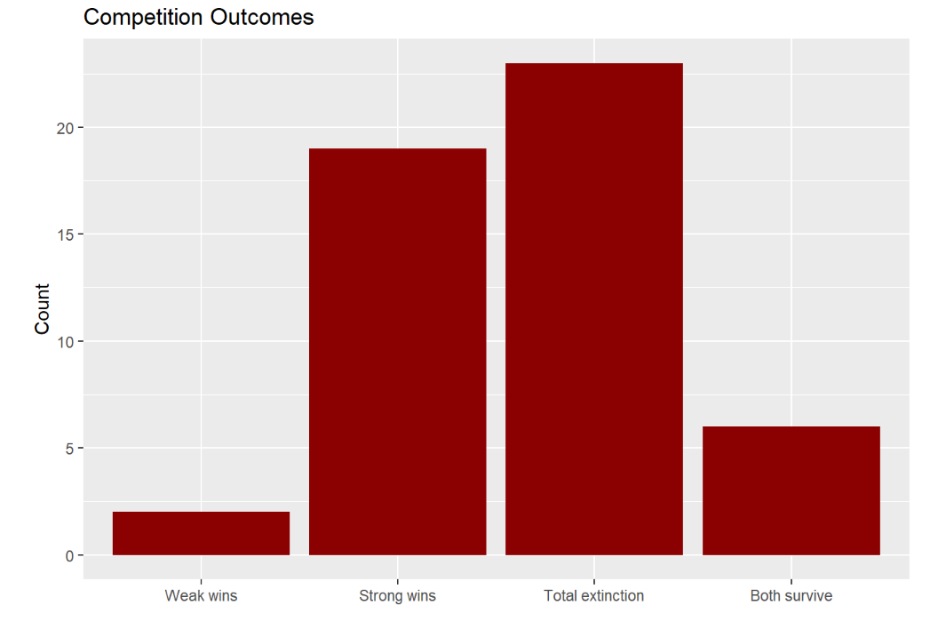
Figure 6.1: Barplot, showing the results of the competition between the two bacterial strains, on the x-axis the four possible outcomes, that were calculated: “weak wins, strong wins, total extinction, both survive”, on the y-axis the counts of each outcome (how often each outcome occurs).
Parameters used for this plot:
init_wd <- 60, init_wb <- 0, init_sd <- 60, init_sb <- 0. decay_rate_wm <- 0.05. decay_rate_sm <- 0.1, max_gen <- 1000, no_replicates <- 50
s_values_wm <- c(0.10, 0.15, 0.20)
s_values_sm <- c(0.25, 0.30, 0.35)
m_values_wm <- c(4e-5, 5e-4, 6e-3)
m_values_sm <- c(7e-5, 8e-4, 9e-3)

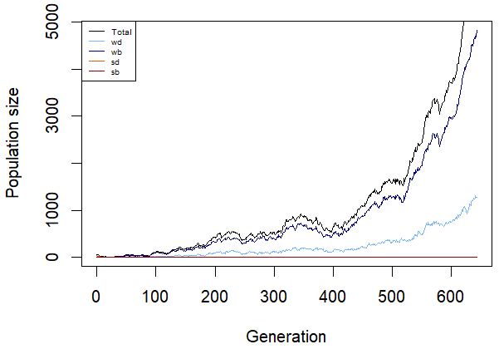
Figure 7.1: Shows the development of one population and how the frequencies of the mutants change. On the x-axis is the generation with a maximum of 5000, while the y-axis represents the population size with a maximum of 600. The initial number of individuals for the deleterious mutants is 30, while there are no beneficial individuals in the beginning. In this output the weak mutations take over the population and rescue it.
Parameters used for the plot:
init_wd <- 30, init_wb <- 0, init_sd <- 30, init_sb <- 0, m_rate_wm <- 0.05, m_rate_sm <- 0.07, decay_rate_wm <- 0.05, decay_rate_sm <- 0.1, s_wm <- 0.1, s_sm <- 0.2

Figure 7.2: Displays the development of one population and how the frequencies of the mutants change. On the x-axis is the generation with a maximum of 30, while the y-axis represents the population size with a maximum of 30. The initial number of individuals for the not advantageous mutants is 30. In the beginning are no beneficial mutants. In this graph extinction can be observed approximately at the 30th generation.
Parameters used for the plot:
init_wd <- 30, init_wb <- 0, init_sd <- 30, init_sb <- 0, m_rate_wm <- 0.05, m_rate_sm <- 0.07, decay_rate_wm <- 0.05, decay_rate_sm <- 0.1, s_wm <- 0.1, s_sm <- 0.2

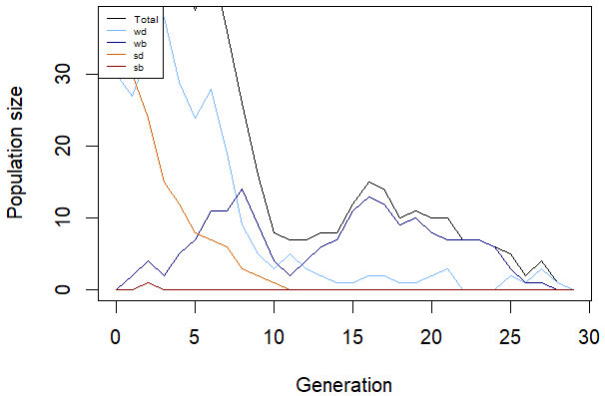
Figure 7.2: Displays the development of one population and how the frequencies of the mutants change. On the x-axis is the generation with a maximum of 30, while the y-axis represents the population size with a maximum of 30. The initial number of individuals for the deleterious mutants is 30, while there are no beneficial individuals in the beginning. In this output the population goes extinct, approximately at the 30th generation.
Parameters used for the plot:
init_wd <- 30, init_wb <- 0, init_sd <- 30, init_sb <- 0, m_rate_wm <- 0.05, m_rate_sm <- 0.07, decay_rate_wm <- 0.05, decay_rate_sm <- 0.1, s_wm <- 0.1, s_sm <- 0.2

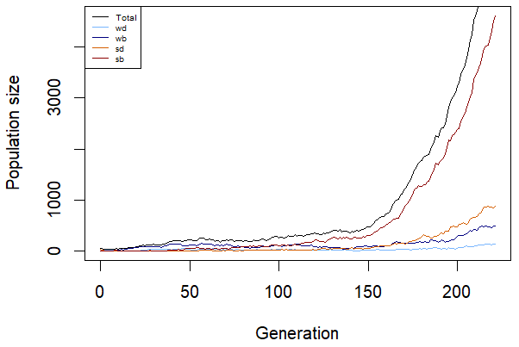
Figure 7.3: Represents the development of one population and how the frequencies of the mutants change. On the x-axis is the generation with a maximum of 200, while the y-axis represents the population size with a maximum of 4000. The initial number of individuals for the not advantageous mutants is 30. In the beginning are no beneficial mutants. In this graph the start of a possible coexistence between the strong mutants and weak beneficial individuals can be observed starting approximately at the 150th generation.
Parameters used for the plot:
init_wd <- 30, init_wb <- 0, init_sd <- 30, init_sb <- 0, m_rate_wm <- 0.05, m_rate_sm <- 0.07, decay_rate_wm <- 0.05, decay_rate_sm <- 0.1, s_wm <- 0.1, s_sm <- 0.2

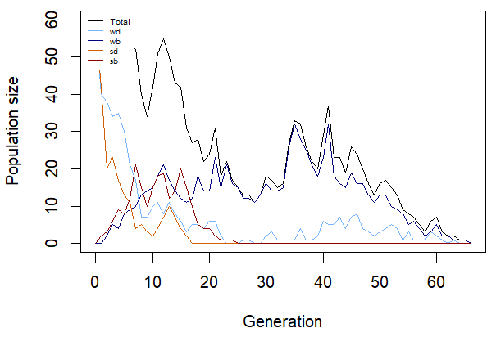
Figure 8.1: Shows the development of one population and how the frequencies of the mutants change. On the x-axis is the generation with a maximum of 60, while the y-axis represents the population size with a maximum of 60. The initial number of individuals for the detrimental mutants is 60, while there are no beneficial ones in the beginning. The output shows extinction by the 60th generation.
Parameters used for the plot:
init_wd <- 60, init_wb <- 0, init_sd <- 60, init_sb <- 0, m_rate_wm <- 0.05, m_rate_sm <- 0.07, decay_rate_wm <- 0.05, decay_rate_sm <- 0.1, s_wm <- 0.1, s_sm <- 0.2

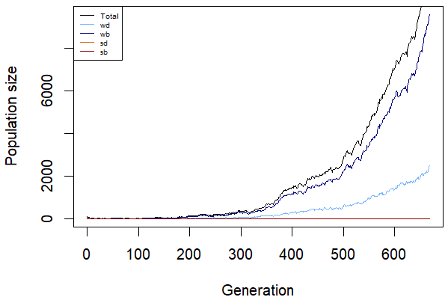
Figure 8.2: Represents the development of one population and how the frequencies of the mutants change. On the x-axis is the generation with a maximum of 600, while the y-axis represents the population size with a maximum of 8000. The initial number of individuals for the detrimental mutants is 60, while there are no beneficial ones in the beginning. The output shows the rescue by the weak individuals with a pattern of exponential growth.
Parameters used for the plot:
init_wd <- 60, init_wb <- 0, init_sd <- 60, init_sb <- 0, m_rate_wm <- 0.05, m_rate_sm <- 0.07, decay_rate_wm <- 0.05, decay_rate_sm <- 0.1, s_wm <- 0.1, s_sm <- 0.2

Figure 10.1: Shows the outcome of 30 populations, each line represents one population. One the x-axis is the generation with the maximum of 1000 and on the y-axis is the population size displayed, with the maximum of 1400. The initial number of individuals for each mutant is 30. The grey lines indicate that this population went extinct before the 1000th generation. In this case all populations went extinct before the 1000th generation.
Parameter used for this plot:
init_wd <- 30, init_wb <- 30, init_sd <- 30, init_sb <- 30, m_rate_wm <- 0.003, m_rate_sm <- 0.005, decay_rate_wm <- 0.1, decay_rate_sm <- 0.2, max_gen <- 1000, no_replicates <- 30, s_wm <- 0.1, s_sm <- 0.2
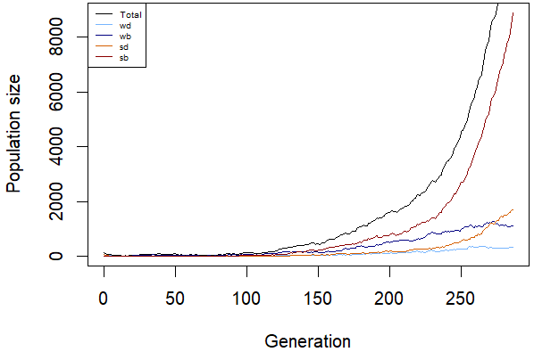
Figure 8.3: Displays the development of one population and how the frequencies of the mutants change. On the x-axis is the generation with a maximum of 250, while the y-axis represents the population size with a maximum of 8000. The initial number of individuals for the detrimental mutants is 60, while there are no beneficial ones in the beginning. The graph shows a possible start of coexistence between the mutants with a pattern of exponential growth.
Parameters used for the plot:
init_wd <- 60, init_wb <- 0, init_sd <- 60, init_sb <- 0, m_rate_wm <- 0.05, m_rate_sm <- 0.07, decay_rate_wm <- 0.05, decay_rate_sm <- 0.1, s_wm <- 0.1, s_sm <- 0.2

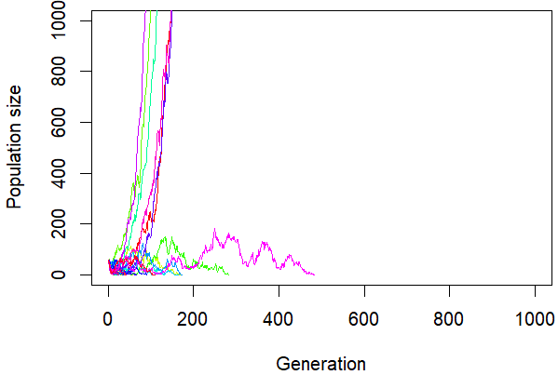
Figure 9.1: Shows the outcome of 30 populations, each line represents one population. One the x-axis is the generation with the maximum of 1000 and on the y-axis is the population size displayed, with the maximum of 1000. The initial number of individuals for the detrimental mutants is 30 but there are no beneficial individuals at the beginning. The output represents 6 populations that thrive early and two populations that persist some generations until they go extinct, as well as the remaining ones.
Parameter used for this plot:
init_wd <- 30, init_wb <- 0, init_sd <- 30, init_sb <- 0, m_rate_wm <- 0.05, m_rate_sm <- 0.07, decay_rate_wm <- 0.05, decay_rate_sm <- 0.1, max_gen <- 1000, no_replicates <- 30, s_wm <- 0.1, s_sm <- 0.2

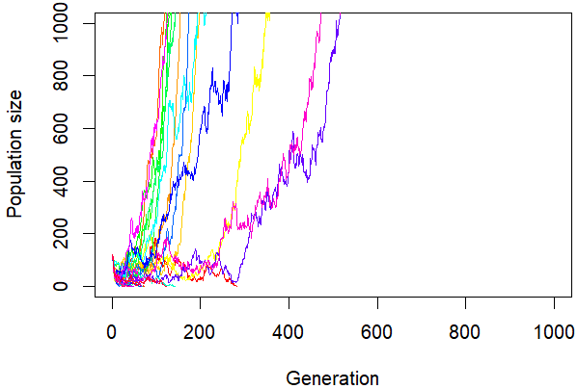
Figure 10.1: Displays the outcome of 30 populations, each line represents one population. One the x-axis is the generation with the maximum of 1000 and on the y-axis is the population size, with the maximum of 1000. The initial number of the detrimental mutants is 60, while there are no beneficial ones at the start. The simulation shows that 12 populations thrive and grow exponentially with varying slopes. Multiple populations persist longer than the other populations (>200 generations) that go extinct but also don’t persist in the end.
Parameter used for this plot:
init_wd <- 60, init_wb <- 0, init_sd <- 60, init_sb <- 0, m_rate_wm <- 0.05, m_rate_sm <- 0.07, decay_rate_wm <- 0.05, decay_rate_sm <- 0.1, max_gen <- 1000, no_replicates <- 30, s_wm <- 0.1, s_sm <- 0.2

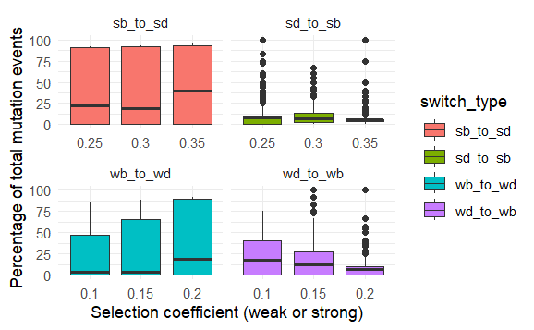
Figure 15: Shows the percentage of mutation events on the y-axis and the corresponding selection coefficients on the x-axis. The initial population size is 60. The percentage of backmutations increases with a higher selection coefficient in both strains and on the same time the percentage of mutations from deleterious to beneficial individuals decrease with a higher selection coefficient.
init_wd <- 30, init_wb <- 0, init_sd <- 30, init_sb <- 0, decay_rate_wm <- 0.05, decay_rate_sm <- 0.1, s_wm <- 0.1, s_sm <- 0.2, max_gen <- 1000, no_replicates <- 50
s_values_wm <- c(0.10, 0.15, 0.20)
s_values_sm <- c(0.25, 0.30, 0.35)

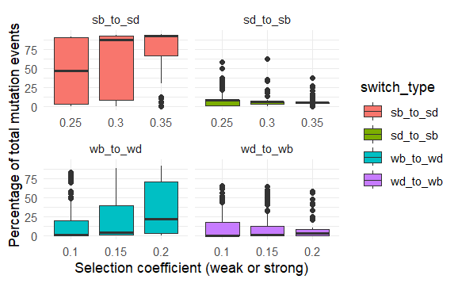
Figure 16: Shows the percentage of mutation events on the y-axis and the corresponding selection coefficients on the x-axis. In the beginning are 60 individuals per detrimental mutants. The percentage of backmutations increases with a higher selection coefficient in both strains and on the same time the percentage of mutations from deleterious to beneficial individuals decrease with a higher selection coefficient.
init_wd <- 60, init_wb <- 0, init_sd <- 60, init_sb <- 0, decay_rate_wm <- 0.05, decay_rate_sm <- 0.1, s_wm <- 0.1, s_sm <- 0.2, max_gen <- 1000, no_replicates <- 50
s_values_wm <- c(0.10, 0.15, 0.20)
s_values_sm <- c(0.25, 0.30, 0.35)

